CO5_AT2 Pseudocode Writing Task (Algorithm Design)
Name: Lavanya
Regno: 192521271
Course name: Design and analysis of algorithms
Course code: CSA0613
Question 23
Feedback Vertex Set Problem
Design a pseudocode using Backtracking to remove minimum vertices to eliminate cycles. Clearly identify inputs (graph) and output (vertex set). Develop an algorithm to explore vertex subsets. Use loops and recursion effectively. Apply pruning to avoid unnecessary removals. Ensure pseudocode clarity. Handle all cases.

1. Objective
The main objective of this project is to design and implement a Backtracking algorithm to solve the Feedback Vertex Set Problem. The algorithm finds the minimum number of vertices that need to be removed from an undirected graph so that the remaining graph contains no cycles.
2. Problem Description
A graph may contain one or more cycles. The Feedback Vertex Set Problem determines the smallest set of vertices whose removal eliminates all cycles from the graph.
Given an undirected graph:
$$G=\left(V , E\right)$$
we need to find a minimum set:
$$F⊆V$$
such that:
$$G-F$$
is an acyclic graph.
The set F is called the Feedback Vertex Set.
3.Algorithm Used
The algorithm uses Backtracking.
For every vertex, the algorithm considers two possibilities:
- Remove the vertex.
- Keep the vertex.
The algorithm recursively explores these possibilities.
If the remaining graph becomes acyclic, the current set of removed vertices is considered a valid solution.
The algorithm keeps the smallest valid set found.
4.Time Complexity
For a graph containing V vertices, there can be up to:
$$2^{V}$$
possible subsets of vertices.
Cycle detection takes:
$$O\left(V+E\right)$$
Therefore, the worst-case time complexity is approximately:
$$O\left(2^{V}\left(V+E\right)\right)$$
Pruning can reduce the actual number of branches explored.
5. Space Complexity
The recursion depth can be at most V.
Therefore, the auxiliary space required by recursion is:
$$O\left(V\right)$$
The graph itself requires:
$$O\left(V+E\right)$$
space when represented using an adjacency list.
6.Analysis
Correctness
The algorithm considers both possibilities for every vertex:
- The vertex is removed.

Therefore, all possible vertex subsets that could form a feedback vertex set are considered unless eliminated by a valid pruning condition.
Whenever the remaining graph becomes acyclic, the current removed set is a valid feedback vertex set.
The algorithm compares its size with the current best solution and stores it only when it is smaller.
Therefore, the final result is a minimum feedback vertex set.
Time Complexity
For $n$vertices, there can be up to:
$$2^{n}$$
possible subsets.
For each subset, cycle detection can take approximately:
$$O\left(V+E\right)$$
Therefore, the worst-case complexity is approximately:
$$O\left(2^{V}\left(V+E\right)\right)$$
The pruning condition can significantly reduce the number of branches explored in practice.
7.Space Complexity
The recursion can have depth up to $V$, so the recursion stack requires:
$$O\left(V\right)$$
additional space, apart from the graph representation.

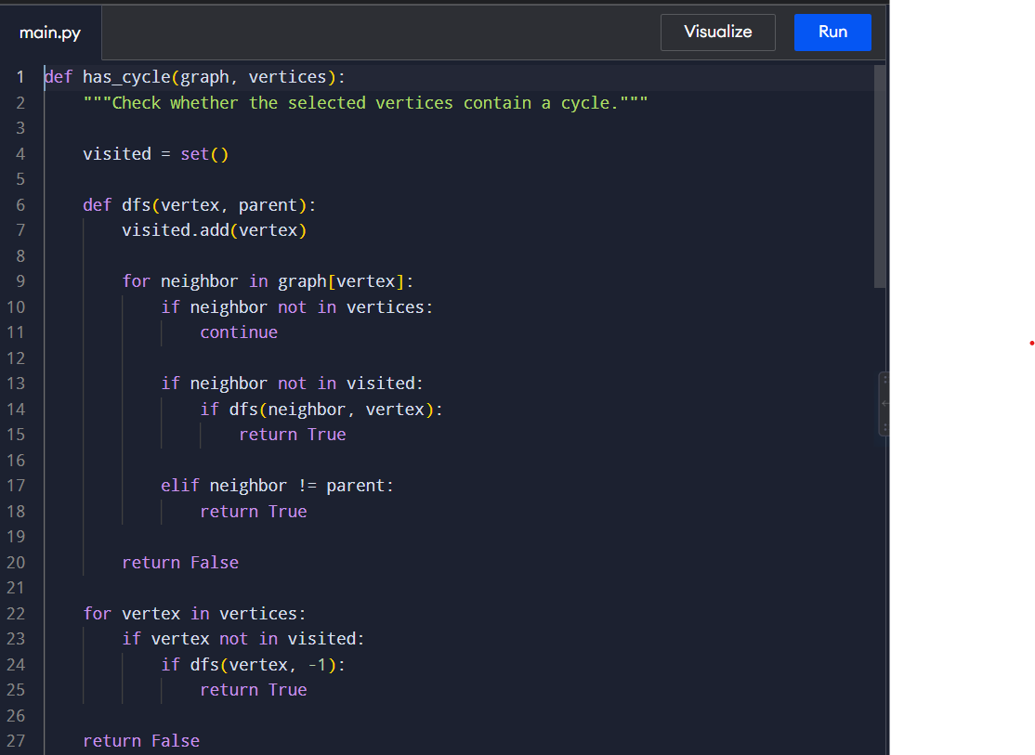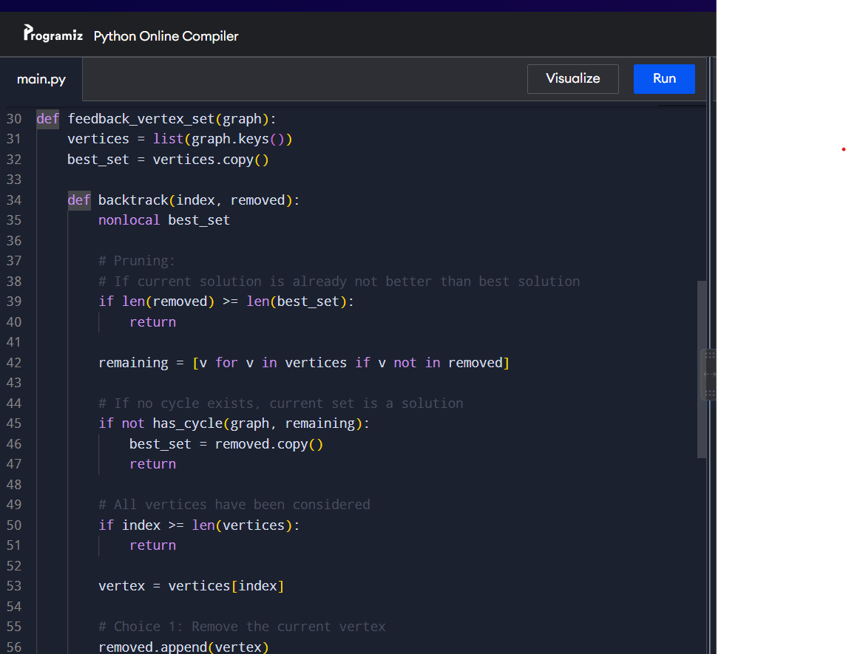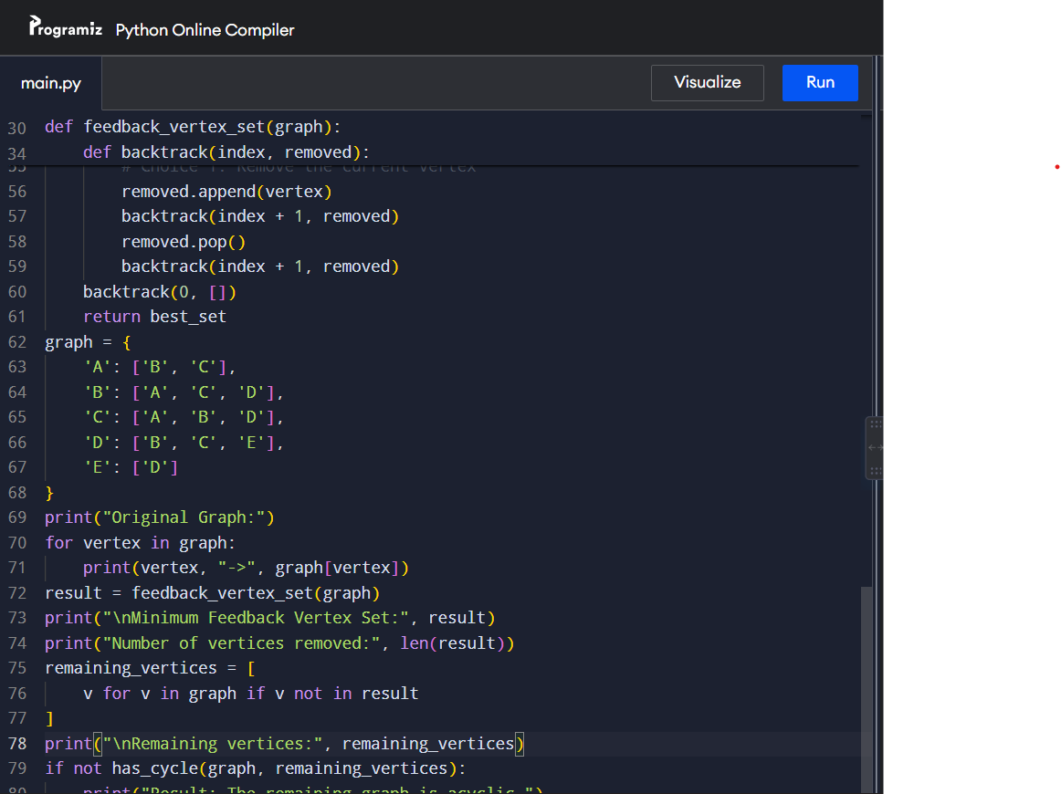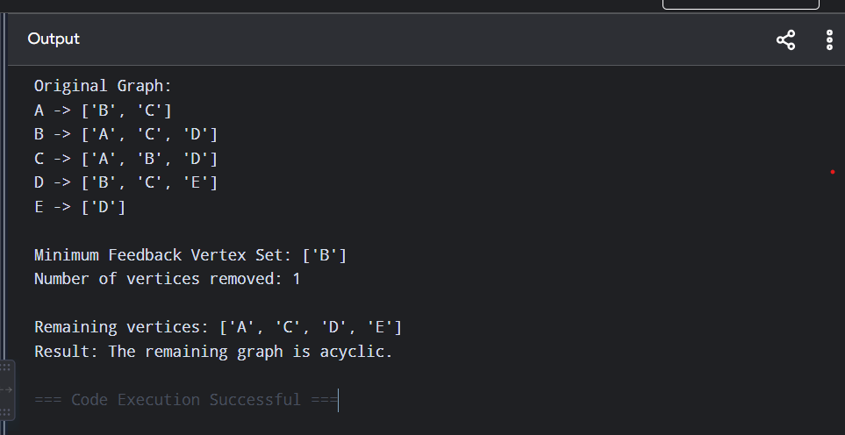

Conclusion:
The Feedback Vertex Set Problem was implemented using a Backtracking algorithm. The algorithm explores possible combinations of removed vertices and uses DFS to check whether cycles remain. A pruning technique is applied to avoid unnecessary branches when the current solution cannot improve the best solution found so far. Thus, the algorithm successfully identifies a minimum set of vertices whose removal eliminates all cycles from the given graph.

